**Choose the most appropriate answer for questions 1-16: (16 X 0.75 = 12 marks)**

|  |  |  |
| --- | --- | --- |
| 1. In Phase-I clinical trials, we: | | |
| 1. Test pharmacological action | | |
| 1. Test drug on healthy volunteers rather than patients | | |
| 1. Test drug on thousands of volunteers | | |
| 1. Use computer software to predict drug activity | | |
| 1. None of the above | | |
|  | | |
|  | | |
| 1. Lead optimization means: | | |
| 1. To find new lead compound from large number of drugs | | |
| 1. To modify the structure of the lead to improve activity | | |
| 1. To modify the structure of the lead to reduce toxicity | | |
| 1. Always result in drugs better than the lead | | |
| 1. Only b and c are correct | | |
|  | | |
| 1. The followings are possible source for identifying a lead compound: | | |
| 1. Random screening of compounds regardless their possible activity | | |
| 1. Metabolites of well known drugs | | |
| 1. Structural similarity studies | | |
| 1. Only a and b | | |
| 1. a, b and c are possible | | |
|  | | |
| 1. The following is true regarding the role of Auxophoric groups: | | |
| 1. Could not have any role | | |
| 1. Are essential for drug target binding | | |
| 1. Always play a role in improving drug solubility | | |
| 1. Do not interfere with pharmacophoric groups and their relative orientations | | |
| 1. None of the above | | |
| 1. For structurally specific drugs, the following is true: | | |
| 1. Can accept many structural modification without affecting activity | | |
| 1. Are sensitive to any minor modification in structure | | |
| 1. Are drugs that are have specific biological target to bind with | | |
| 1. Both b and c | | |
| 1. Both a and c | | |
|  | | |
| 1. The following is true regarding lead compound: | | |
| 1. Is a starting point in most drug discovery processes | | |
| 1. An ideal drug for both activity and safety | | |
| 1. Could be modified for optimization | | |
| 1. Never be a drug | | |
| 1. Both a and c | | |
|  | | |
| 1. For the process of drug discovery, you must have access to: | | |
| 1. A running bioassay | | |
| 1. Instrumental analysis for drug identification | | |
| 1. Enzymatic assay if inhibitors are the target | | |
| 1. All of the above | | |
|  | | |
| 1. Fexofenadine was obtained from which of the following lead sources: | | |
| 1. Random screening | | |
| 1. Metabolic studies of a known drug | | |
| 1. Clinical observation studies | | |
| 1. Computer aided drug design studies | | |
| 1. None of the above | | |
|  | | |
| 1. The following is true about pharmacophoric groups: | | |
| 1. Are groups found in drug essential for activity regardless their arrangement | | |
| 1. Play the major role in drug target interactions | | |
| 1. Only important for pharmacokinetic profile | | |
| 1. Essential for drug absorption | | |
| 1. Only a and b are correct | | |
|  | | |
| 1. The following is true regarding homologation: | | |
| 1. Means to make drug more rigid, not flexible | | |
| 1. It is a chain elongation | | |
| 1. It was suitable method for acetylcholine midification | | |
| 1. Both b and c | | |
|  | | |
| 1. The following drug has both antibacterial and hypoglycaemic activity: | | |
|  | |  |
|  | |  |
|  | |  |
|  | |  |
| 1. Both b and c are correct | |  |
|  | |  |
| 1. The modification of Acetylcholine to Arecoline has: | | |
| 1. Improved activity | | |
| 1. Improved chemical stability | | |
| 1. Increased structural flexibility | | |
| 1. Increased water solubility 2. Both a and c | | |
|  | | |
| 1. The following could be an effect of adding a branch to drug structure: | | |
| 1. Might affect the binding to receptor | | |
| 1. Has no effect on drug lipophilicity | | |
| 1. Might make drug highly unstable toward metabolism | | |
| 1. None of the above | | |
|  | | |
| 1. The following groups could be a possible bioisostere for alcoholic OH: | | |
|  |  | |
|  |  | |
|  |  | |
|  |  | |
| 1. I, II and IV | | |
| 1. Only I and IV | | |
| 1. Only I and III | | |
| 1. Only II | | |
|  | | |
| 1. According to chain to ring transformation, the following is true: | | |
| 1. Results in more rigid structure | | |
| 1. Has no effect on drug action | | |
| 1. Means to use aromatic ring because it is stable | | |
| 1. Both a and b are correct | | |
|  | | |
| 1. Receptor agonist: | | |
|  | | |
| 1. Are drugs mimic the natural ligand structure | | |
| 1. Will give the same active conformer of receptor | | |
| 1. Its binding is stronger and different from that of natural ligand | | |
| 1. Only a and b are correct | | |
|  | | |
|  | | |
|  | | |
|  | | |
|  | | |
|  | | |
|  | | |

**Question-17: (3 marks)**

**Rotigotine is a drug used in Parkinson's, is a derivative of Dopamine, answer questions that follow their structures:**



1. **Why it was not possible to give dopamine as a drug for Parkinson's?**
2. **explain how Rotigotine is a dopamine agonist although it is far different in structure?**

**Question-18: (2 marks)**

Give in a brief summary the main steps in any drug discovery process starting from the target identification until drug reaching the market (put your answer as a flow chart)

**Questoin-19: (3 marks)**

Use the fragmentation constant table to calculate the LogP for the cholinergic antagonist cyclpentolate, and then based on your result do you expect this drug to be suitable for oral administration? Explain your answer



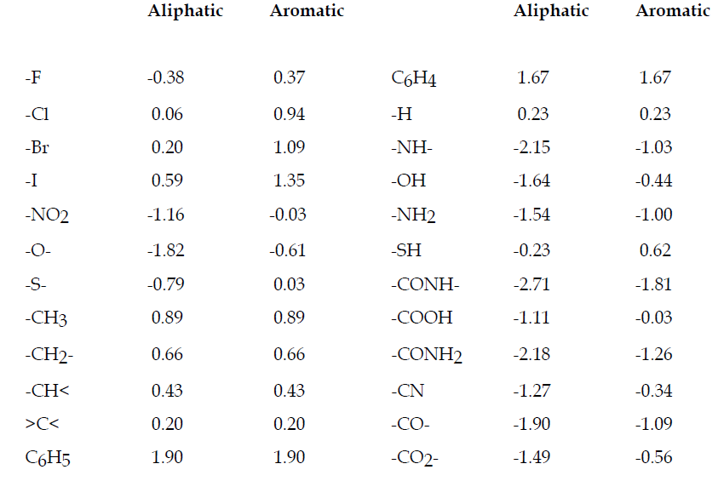

**Answer Sheet for questions 1-16**

|  |  |  |  |  |  |  |  |  |  |  |  |
| --- | --- | --- | --- | --- | --- | --- | --- | --- | --- | --- | --- |
| **Q** |  | | | | | **Q** |  | | | | |
| **1** | **a** | **b** | **c** | **d** | **e** | **9** | **a** | **b** | **c** | **d** | **e** |
| **2** | **a** | **b** | **c** | **d** | **e** | **10** | **a** | **b** | **c** | **d** | **e** |
| **3** | **a** | **b** | **c** | **d** | **e** | **11** | **a** | **b** | **c** | **d** | **e** |
| **4** | **a** | **b** | **c** | **d** | **e** | **12** | **a** | **b** | **c** | **d** | **e** |
| **5** | **a** | **b** | **c** | **d** | **e** | **13** | **a** | **b** | **c** | **d** | **e** |
| **6** | **a** | **b** | **c** | **d** | **e** | **14** | **a** | **b** | **c** | **d** | **e** |
| **7** | **a** | **b** | **c** | **d** | **e** | **15** | **a** | **b** | **c** | **d** | **e** |
| **8** | **a** | **b** | **c** | **d** | **e** | **16** | **a** | **b** | **c** | **d** | **e** |